**Bradshaw Family and Community T-shirt fundraiser**

COST $50.00

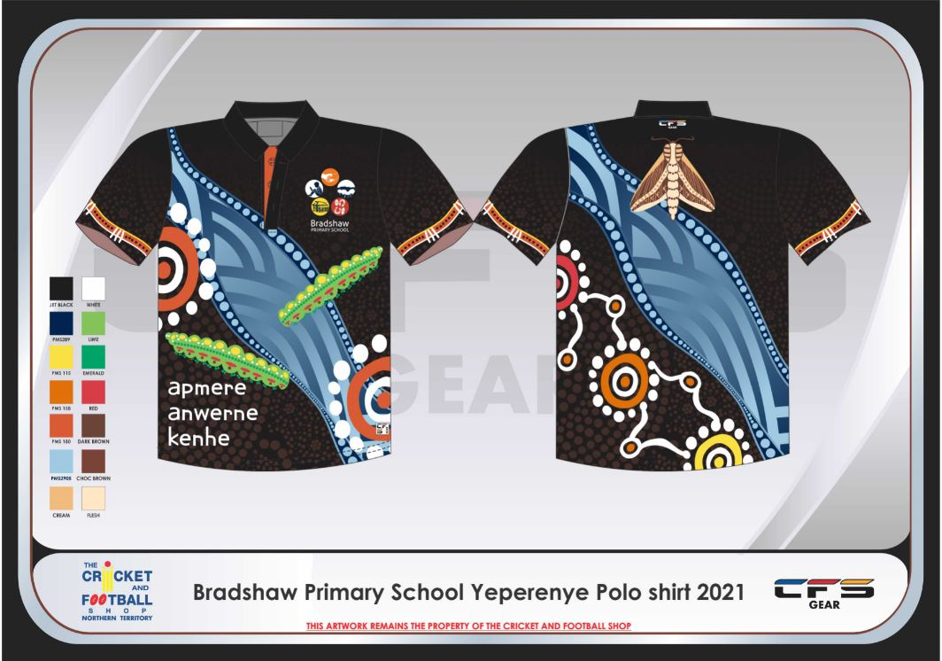

Order yours now!!!

Due to popularity of shirts, a second order will go in

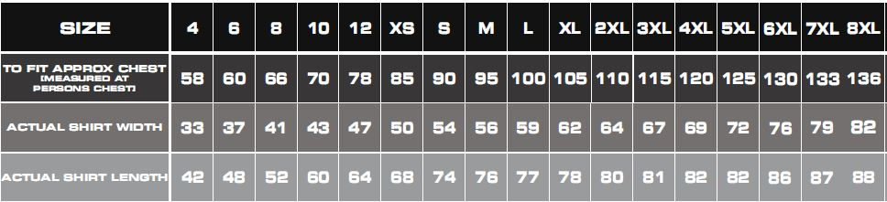

Friday 13th August, 2021

NAME: ____________________________________

PHONE NO: ________________________________

SIZE:_____________________________________

Please enclose payment with order form in an envelope and send to the front office.